LABORATORIYA ISHI №4
Mavzu: PHP orqali MySQL ma’lumotlar bazasiga ulanish
1. Ishning maqsadi
- Tayyor MySQL bazaga PHP orqali ulanish
- SELECT so‘rovlarini bajarish
- INNER JOIN orqali bir nechta jadval ma’lumotlarini chiqarish
- MySQLi (procedural, OOP) va PDO usullarini taqqoslash
- Ular orasidagi farqlarni amaliy ko‘rsatish
2. Nazariy qism
PHP orqali MySQL bilan ishlashning 3 asosiy usuli mavjud:
- MySQLi (Procedural)
- MySQLi (Object-Oriented)
- PDO (PHP Data Objects)


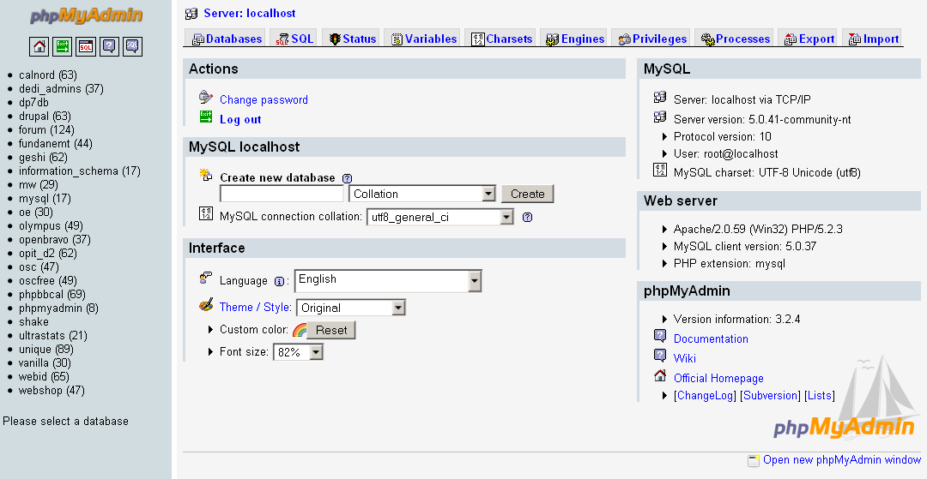
3. Amaliy baza (tayyor database)
Database: db_universitet
3 ta jadval:
fakultetlar
- id (PK)
- nomi
talabalar
- id (PK)
- ism
- kurs
- fakultet_id (FK)
fanlar
- id (PK)
- fan_nomi
- kredit
- talaba_id (FK)
4. Oddiy SELECT so‘rovi
SELECT * FROM talabalar;
5. JOIN so‘rovi
SELECT
talabalar.ism,
talabalar.kurs,
fakultetlar.nomi AS fakultet,
fanlar.fan_nomi
FROM talabalar
INNER JOIN fakultetlar ON talabalar.fakultet_id = fakultetlar.id
INNER JOIN fanlar ON talabalar.id = fanlar.talaba_id;
6. PHP orqali ulanish usullari
6.1 MySQLi – Procedural usul
<?php
$conn = mysqli_connect("localhost", "root", "", "db_universitet");
if (!$conn) {
die("Ulanish xatoligi: " . mysqli_connect_error());
}
$sql = "SELECT * FROM talabalar";
$result = mysqli_query($conn, $sql);
while ($row = mysqli_fetch_assoc($result)) {
echo $row['ism'] . " - " . $row['kurs'] . "<br>";
}
mysqli_close($conn);
?>
Xususiyatlari:
- Oddiy
- Faqat MySQL bilan ishlaydi
- Xavfsizlik PDO ga qaraganda pastroq
6.2 MySQLi – Object Oriented usul
<?php
$conn = new mysqli("localhost", "root", "", "db_universitet");
if ($conn->connect_error) {
die("Xatolik: " . $conn->connect_error);
}
$sql = "SELECT * FROM talabalar";
$result = $conn->query($sql);
while ($row = $result->fetch_assoc()) {
echo $row['ism'] . "<br>";
}
$conn->close();
?>
Xususiyatlari:
- OOP yondashuv
- Professionalroq
- Katta loyihalar uchun qulay
6.3 PDO usuli (Tavsiya etiladi)
<?php
try {
$conn = new PDO("mysql:host=localhost;dbname=db_universitet", "root", "");
$conn->setAttribute(PDO::ATTR_ERRMODE, PDO::ERRMODE_EXCEPTION);
$sql = "SELECT * FROM talabalar";
$stmt = $conn->query($sql);
while ($row = $stmt->fetch(PDO::FETCH_ASSOC)) {
echo $row['ism'] . "<br>";
}
} catch(PDOException $e) {
echo "Xatolik: " . $e->getMessage();
}
?>
Xususiyatlari:
- Turli DB lar bilan ishlaydi (MySQL, PostgreSQL, Oracle)
- Eng xavfsiz
- Prepared Statement kuchli
- try-catch bilan ishlaydi
7. PDO orqali JOIN misoli
<?php
try {
$conn = new PDO("mysql:host=localhost;dbname=db_universitet", "root", "");
$conn->setAttribute(PDO::ATTR_ERRMODE, PDO::ERRMODE_EXCEPTION);
$sql = "SELECT
talabalar.ism,
talabalar.kurs,
fakultetlar.nomi AS fakultet,
fanlar.fan_nomi
FROM talabalar
INNER JOIN fakultetlar
ON talabalar.fakultet_id = fakultetlar.id
INNER JOIN fanlar
ON talabalar.id = fanlar.talaba_id";
$stmt = $conn->query($sql);
echo "<table border='1'>";
echo "<tr><th>Ism</th><th>Kurs</th><th>Fakultet</th><th>Fan</th></tr>";
while ($row = $stmt->fetch(PDO::FETCH_ASSOC)) {
echo "<tr>
<td>{$row['ism']}</td>
<td>{$row['kurs']}</td>
<td>{$row['fakultet']}</td>
<td>{$row['fan_nomi']}</td>
</tr>";
}
echo "</table>";
} catch(PDOException $e) {
echo "Xatolik: " . $e->getMessage();
}
?>
8. Usullarni taqqoslash
Xususiyat | MySQLi Procedural | MySQLi OOP | PDO
DB turi | Faqat MySQL | Faqat MySQL | Ko‘p DB
Xavfsizlik | O‘rtacha | Yaxshi | Eng yaxshi
try-catch | Yo‘q | Yo‘q | Bor
Prepared | Bor | Bor | Juda kuchli
Professional | O‘rtacha | Yaxshi | Eng yaxshi

9. Natija
Laboratoriya ishida:
- Tayyor MySQL bazaga ulanish amalga oshirildi
- SELECT so‘rovi bajarildi
- INNER JOIN ishlatildi
- 3 xil PHP usuli taqqoslandi
- PDO eng tavsiya etiladigan usul ekanligi ko‘rsatildi
Topshiriqlar:

22-Elektron kutubxona

Database: db_ekutubxona

Jadvallar:
foydalanuvchi
- id
- ism
- email
kitob
- id
- nomi
- muallif
yuklab_olish
- id
- foydalanuvchi_id (FK)
- kitob_id (FK)
- sana

JOIN vazifa:
Foydalanuvchi + Kitob + Yuklab olish sanasi chiqarish.

Talaba nima qiladi?
- Yuklab_olish jadvali orqali bog‘laydi
- INNER JOIN yozadi
- SELECT orqali chiqaradi
- HTML table shaklida natija beradi

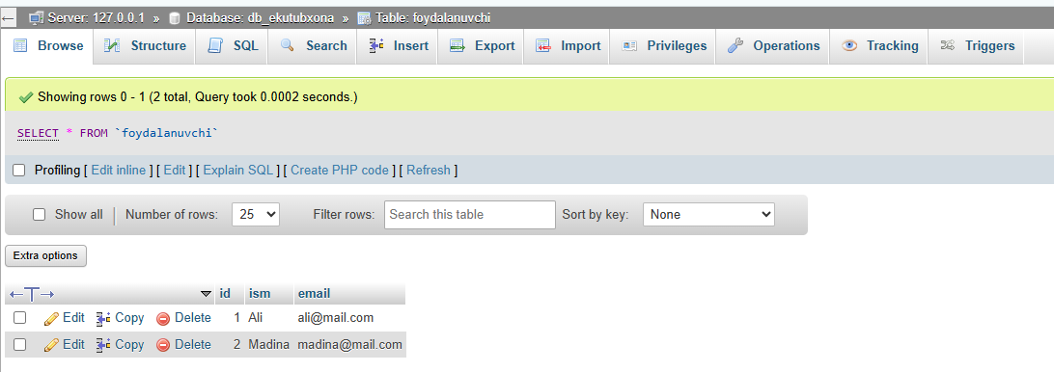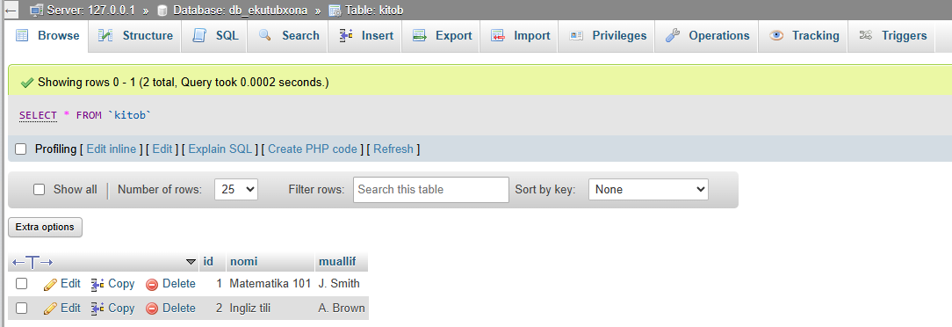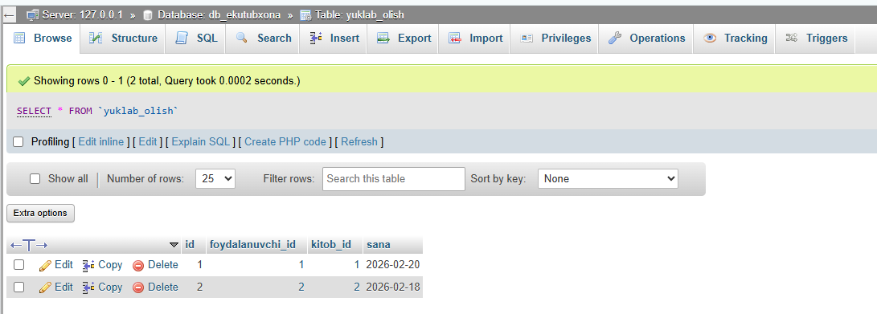
Index.php ga bog’lash kodi:
<?php

try {

$conn = new PDO("mysql:host=localhost;dbname=db_ekutubxona","root","");
$conn->setAttribute(PDO::ATTR_ERRMODE, PDO::ERRMODE_EXCEPTION);

$sql = "SELECT
foydalanuvchi.ism,
foydalanuvchi.email,
kitob.nomi,
kitob.muallif,
yuklab_olish.sana
FROM yuklab_olish
INNER JOIN foydalanuvchi
ON yuklab_olish.foydalanuvchi_id = foydalanuvchi.id
INNER JOIN kitob
ON yuklab_olish.kitob_id = kitob.id";

$stmt = $conn->query($sql);

echo "<h2>Elektron Kutubxona</h2>";

echo "<table border='1' cellpadding='10'>";

echo "<tr>
<th>Foydalanuvchi</th>
<th>Email</th>
<th>Kitob</th>
<th>Muallif</th>
<th>Yuklab olingan sana</th>
</tr>";

while($row = $stmt->fetch(PDO::FETCH_ASSOC)){

echo "<tr>

<td>".$row['ism']."</td>
<td>".$row['email']."</td>
<td>".$row['nomi']."</td>
<td>".$row['muallif']."</td>
<td>".$row['sana']."</td>

</tr>";

}

echo "</table>";

}

catch(PDOException $e){

echo "Xatolik: ".$e->getMessage();

}

?>
